Data_Structure lab 4
Muhammad Shahmeer

Task 1
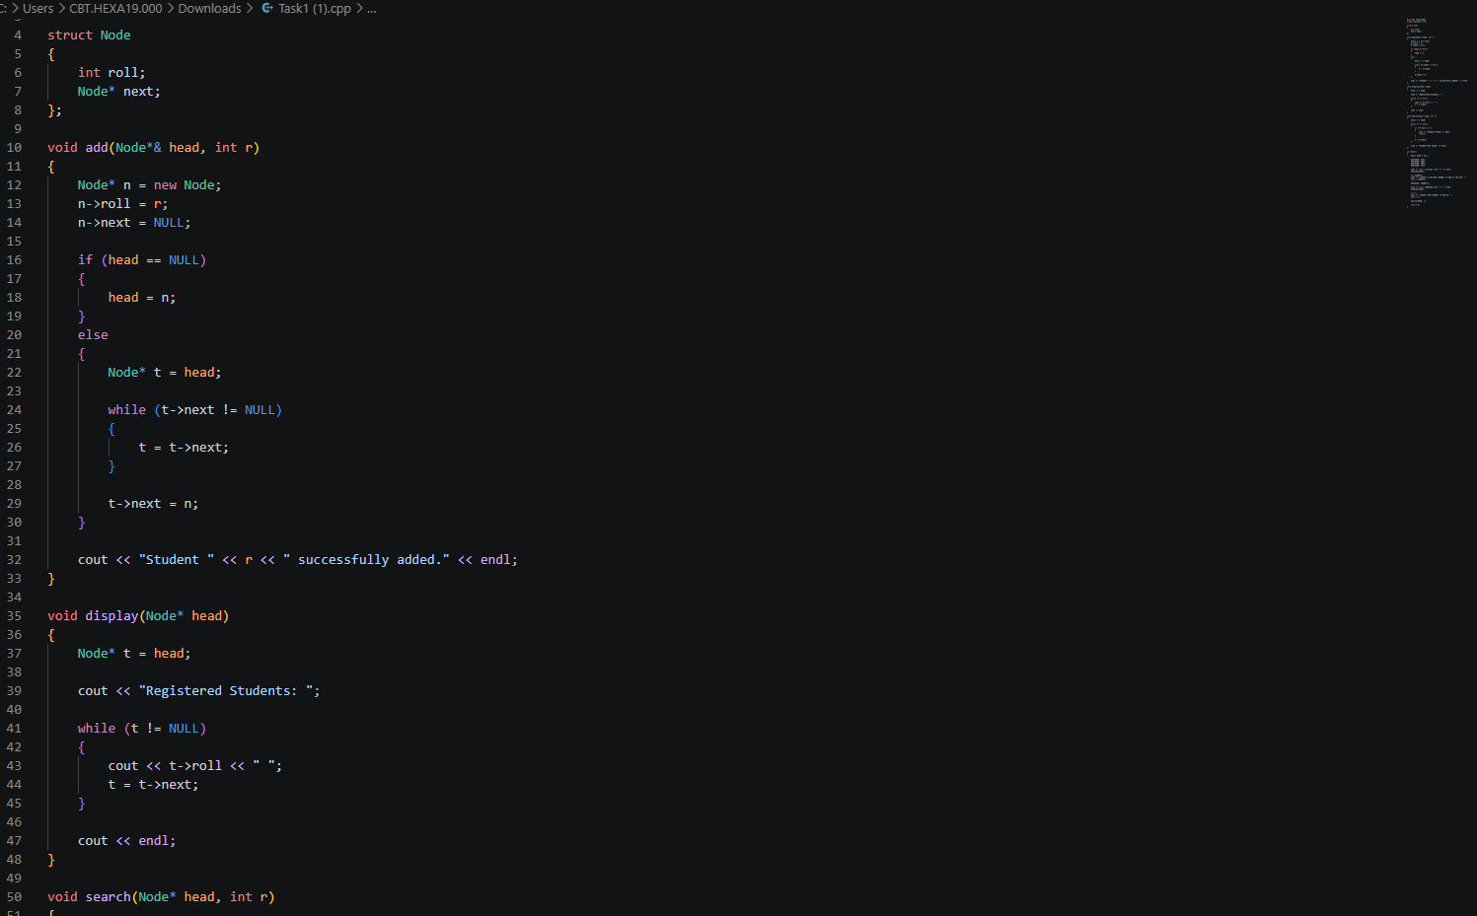

Output

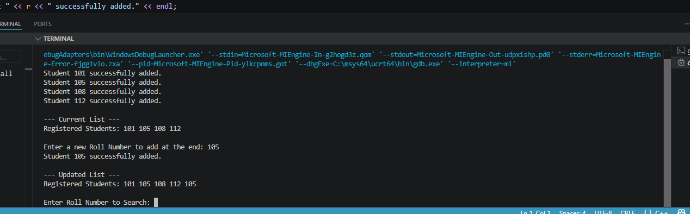

Task 2
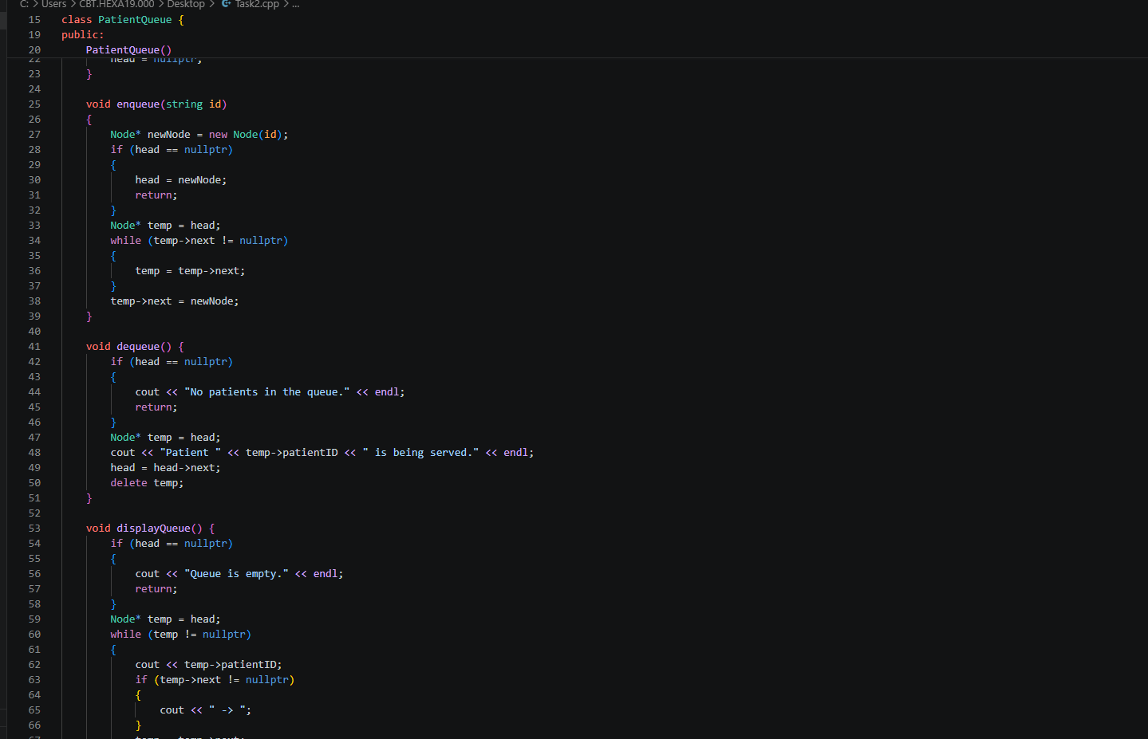

Output
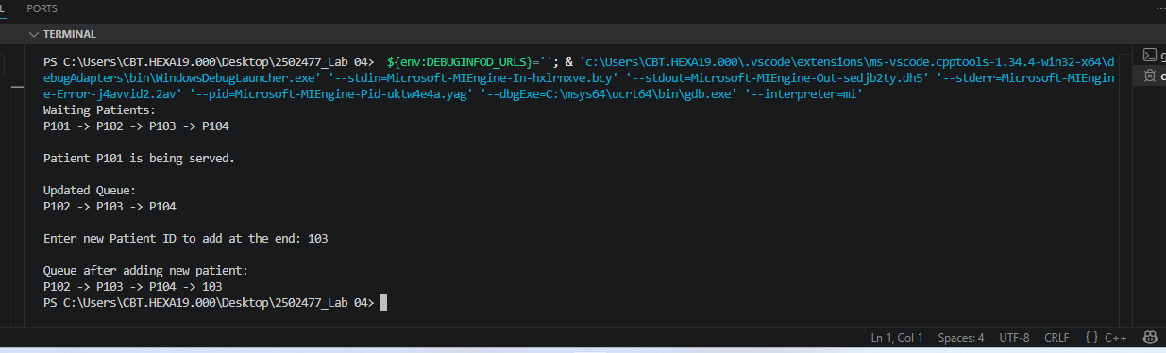

TASK 3
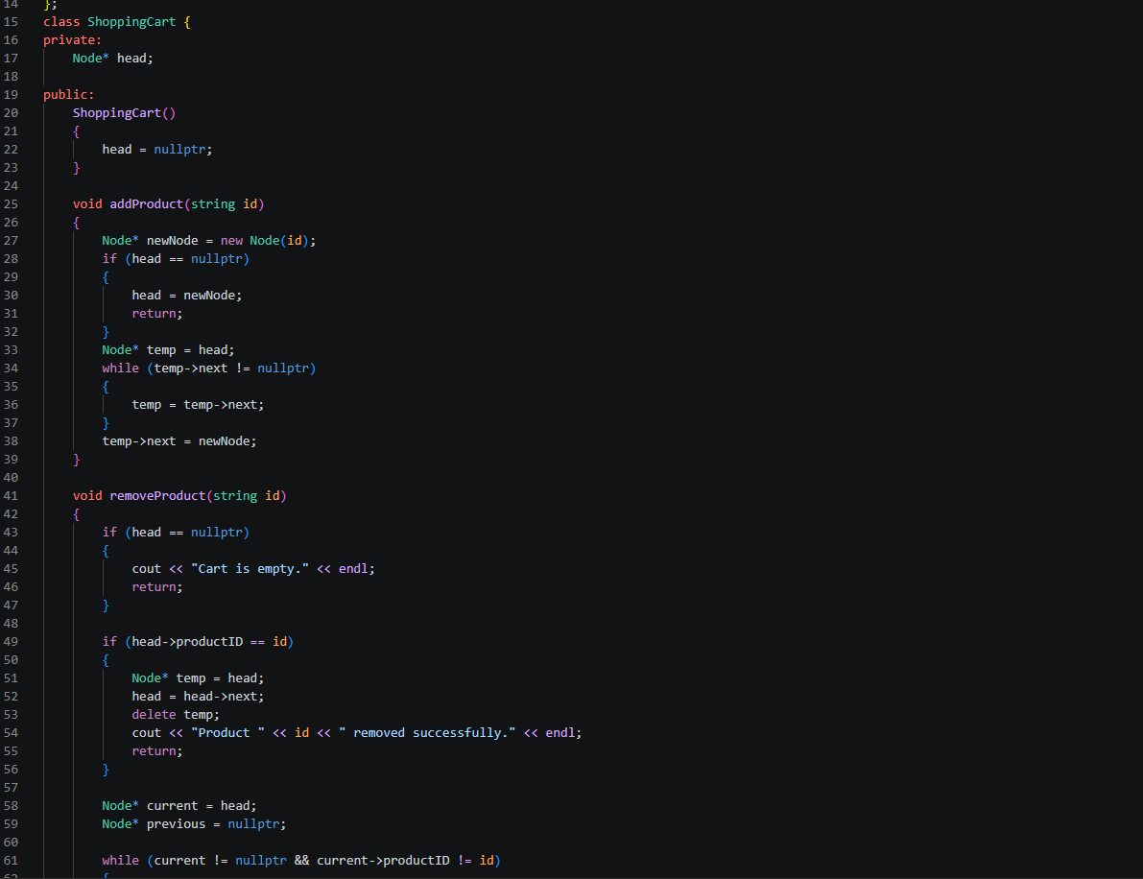

OUTPUT
